Packshot | Naam | Artikelnummer | EAN
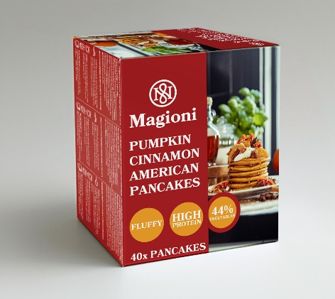 | MAGIONI AMERICAN PANCAKES PUMPKIN CINNAMON 1,6KG | 211702 | 8719324058919
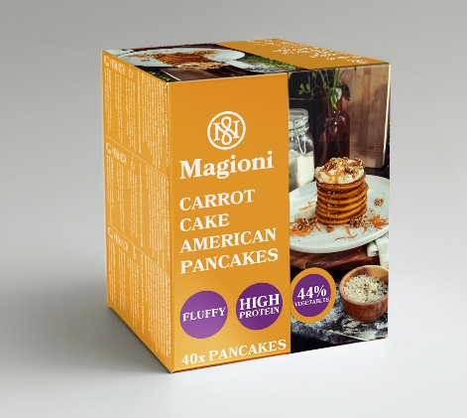 | MAGIONI AMERICAN PANCAKES CARROT CAKE 1,6KG | 211704 | 8719324058926

